IA4

Design Challenge: Smart Home Manager

Design layout of and user interface for both the physical wall-mounted device and it’s touch screen display

1. State the design challenge:
   1. Design the layout of and user interface for both the physical wall-mounted device and it’s touch screen display for a smart home manager.
2. Generate ten or more different design concepts of a system that address the challenge.
   1. Be creative and diverse.

Concept 1:

**Conceptual model:**

This design will allow the user to approach the device with the idea of what they want to do and will allow them to easily navigate the menus to achieve that goal. The interface only shows relevant information at each screen to prevent the user from being overwhelmed. Labels are used to eliminate confusion about operations. If a user wishes to add a new device or remove an existing one, they presumably know where that device is located and so can navigate to that room and select the “add/remove device” button which will bring up a list of available devices to add or remove. Existing devices are listed separately from devices that have not been added to the system to easily distinguish between them. Selecting an item will bring up the options for that item so the user can add or remove the item from the manager or adjust the settings for that device. A scheduling option is available for each device. The display for each room shows the status of each device at a glance.

**Affordances:**

The touch screen affords touching. The touch screen is ubiquitous and because of transfer effects, requires no explanation or instructions. With no visible physical buttons, users will assume a touch interface and press the area of the screen that displays the information that pertains to their desired action.

**Signifiers:**

Each screen is **consistently** labelled at the top to let the user know where they are in the menu. Parenthesized notes have been added to prompt the user to items that can be pressed for actions.

**Mapping:**

To choose a specific room, a map of the house is shown to provide a natural mapping to help the user select the correct room. If we had chosen text with the label of each room, it would be easy to confuse some rooms such as bedrooms for which there can be more than one. Using a pictorial map and allowing the user to press on the room they wish to control removes any confusion.

**Feedback:**

When a user pushes on the screen, the screen will change to the new operation immediately showing them that the action was accepted. An audible notification can also be added if that is desired with a volume low enough to not be offensive but loud enough to be definitively noticed.

**Constraints:**

**Physical:**

The touch screen constrains all action to within the touchable area.

Cultural:

Semantic:

Logical:

**Transfer effects:**

Touch screens are ubiquitous.

Seven stages of action:

1. Establish goal
2. Plan course of action to meet goal
3. Specify sequence of action steps
4. Perform the steps
5. Perceive the state of the system
6. Interpret the perception
7. Compare outcome against goal

**Bridge of execution:**

The user must know at each step what the next action needs to be. As the screen changes, so does the information the new screen provides. Each screen is clearly labelled with it’s title and any operations that can be performed on that screen are labelled as well.

**Bridge of evaluation:**

The user must know that the action they did was successful. When the screen changes to the next operation or values for settings change as the screen is touched let the user know they were successful.

Colors are used in a manner that will minimize the impact on color-blind users. Red and blue text on a white background provide sufficient contrast for users of all color-blind ranges.

The design uses **visual structure**, organizing each window into clear subgroups with spacing between them to denote them as different elements. The schedule controls are **data specific**, they use calendar terminology and icons to distinguish them by their function.

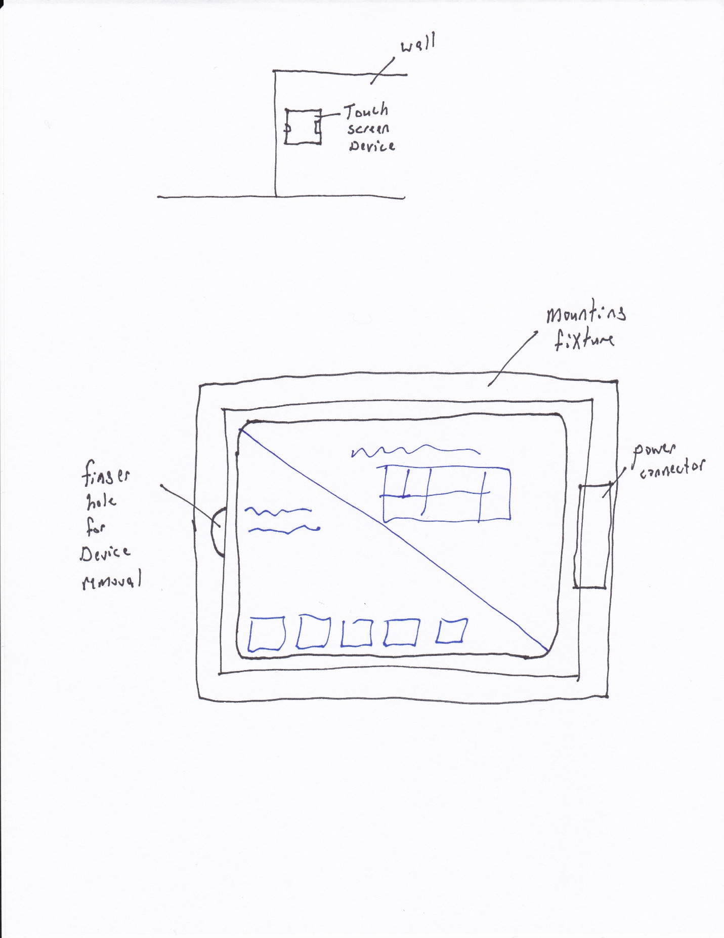

**Figure 1:** Physical device installation in wall, removable touch-device (iPad, Surface, etc.)

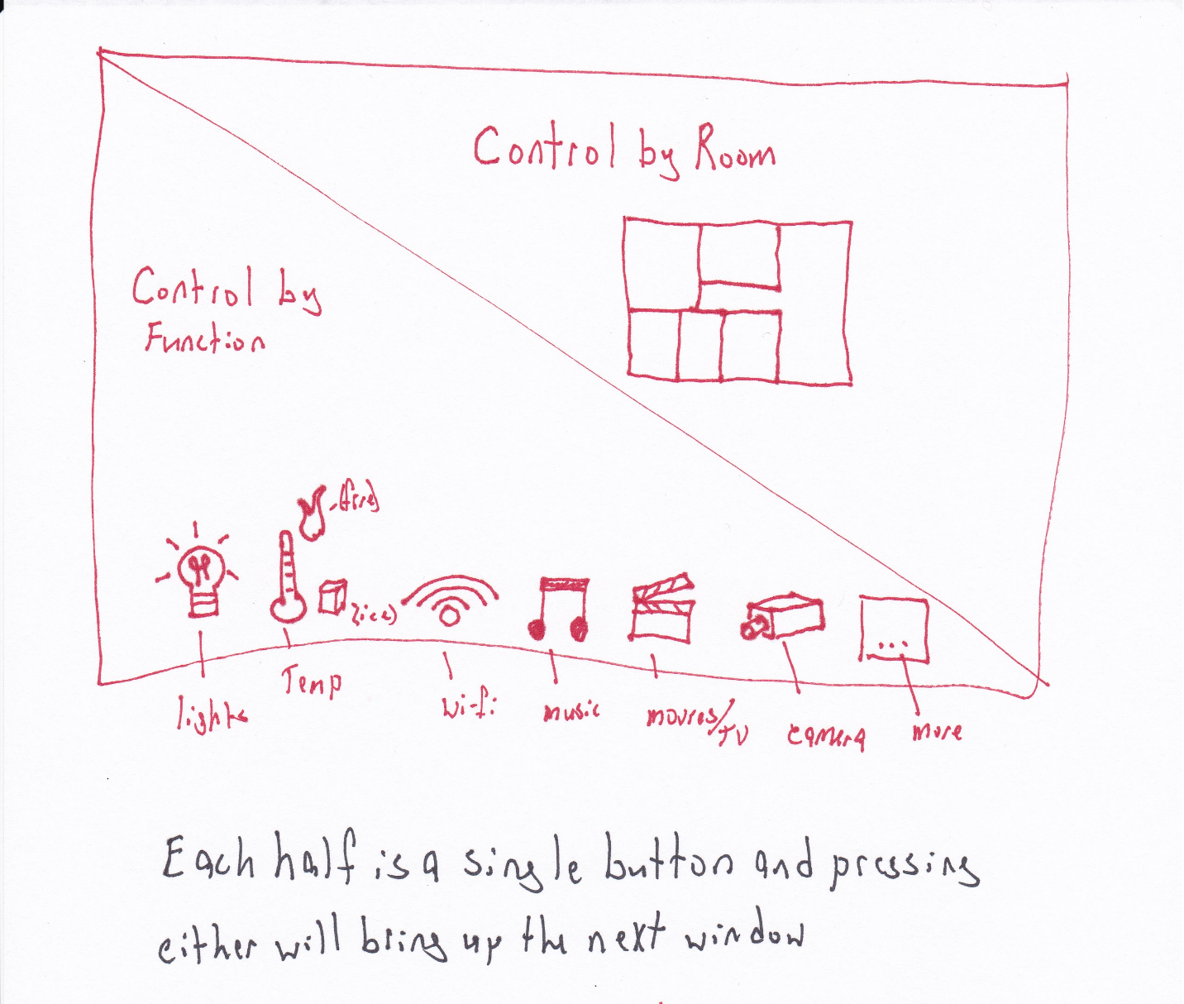

**Figure 1:** Main menu

**Bridge of execution:**

The users **plan** will be to adjust the setting of a device. To **perform** this action, the user can see from the display that there are two options. Each is labelled with the keyword “control” and the sub-function follows. Assuming the user wants to set a schedule for the freezer, they could choose to control by room and press the upper-right portion of the screen.

**Bridge of Evaluation:**

The **interpretation** is slightly ambiguous, the user may select “Control by Function” instead believing that will be the best way to control the temperature since that is a specifically listed function but pressing that button will bring up a new screen that will have a list of each of those elements and will show an option for the refrigerator and one for the thermostat which would eliminate their confusion while still allowing them to select the correct device without having to return to the previous menu.

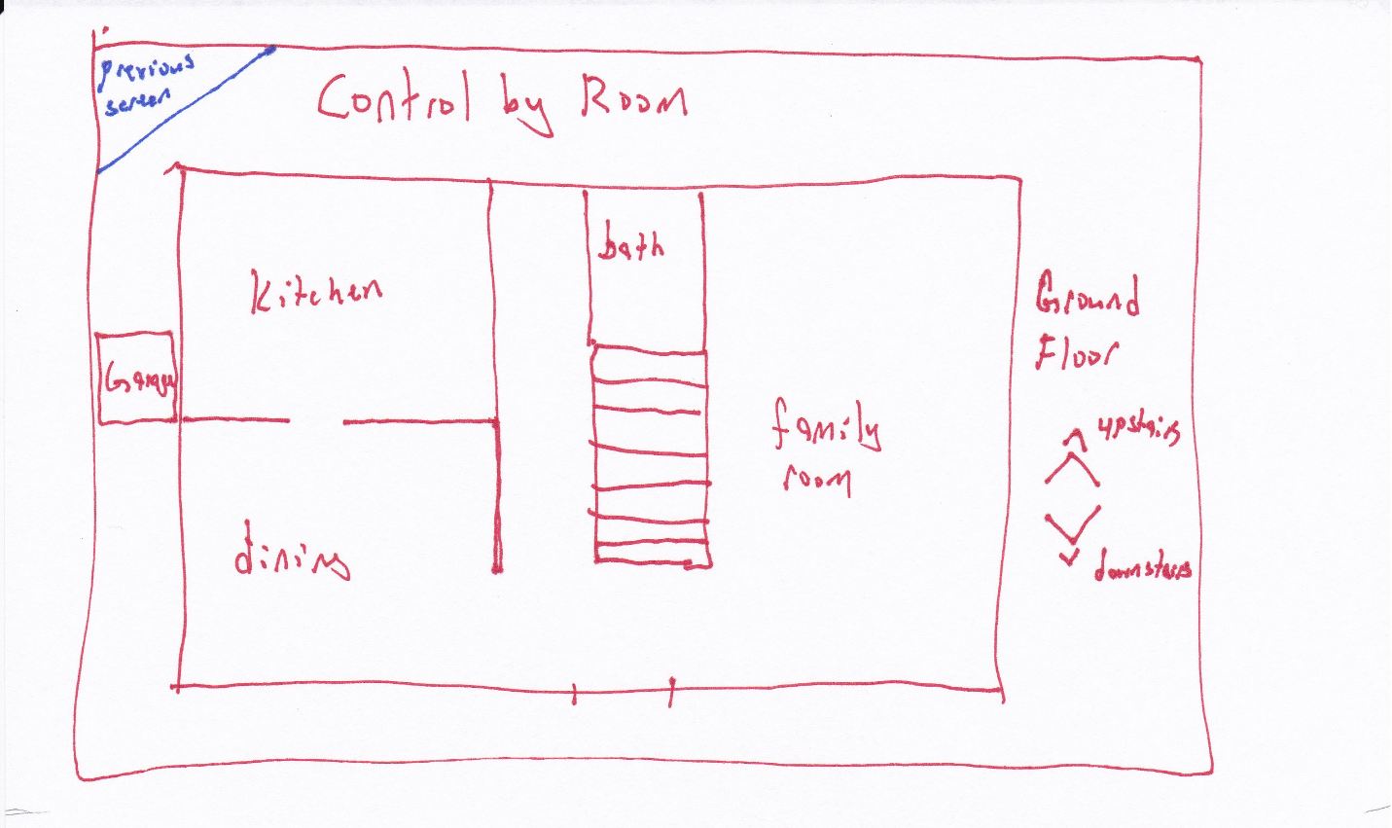

**Figure 2:** Select room, user presses on the room they wish to control

**Bridge of Evaluation:**

The user’s **plan** is to adjust the freezer schedule. The freezer is located in the kitchen. The kitchen is one of the rooms available to select. The user can easily see the next option.

**Bridge of Execution:**

It is not unusual to have a freezer in the garage. The user could **misinterpret** the screen if they believed this to be the case. In that event, selecting the garage will show a list of available devices and if a freezer is not listed, they will have to return to the previous screen, this screen, and make a more appropriate choice. This might be a **cultural constraint** as some people keep bulk foods on hand, some don’t.

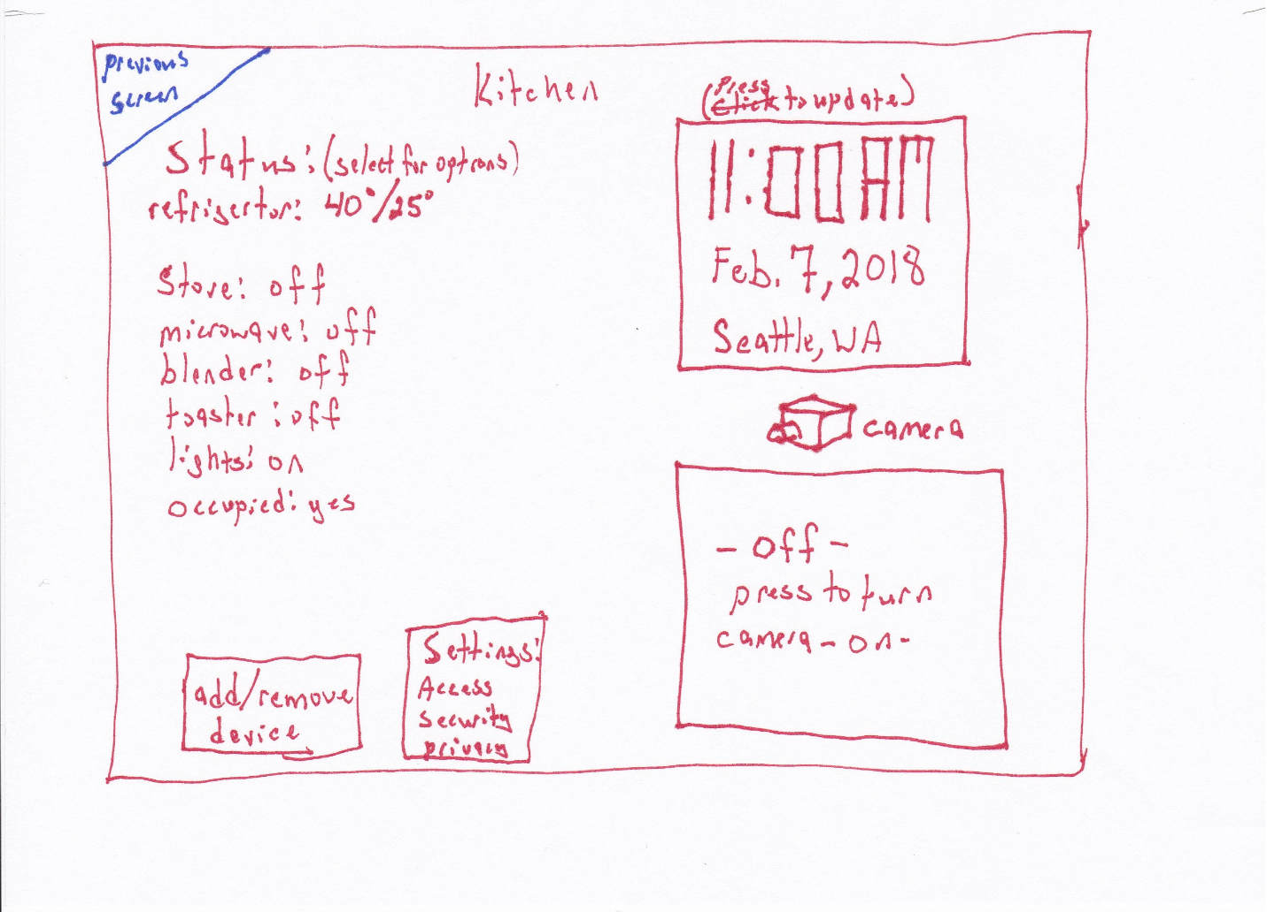

**Figure 3:** Status by room with options to change the settings for each device, add or remove devices, change system settings (this is available in all room displays). The camera and video option can be made to only appear if the room has an enabled camera. It the camera is not installed for a room or has been otherwise disabled, this option will not appear but will be a blank part of the screen. The position of the other elements will not change to preserve window-to-window consistency.

**Bridge of Execution:**

The refrigerator status is shown on the status display and the Status heading states that the user can press the device for more options. The user can easily see what they need to do next to set a schedule for the freezer.

**Bridge of Evaluation:**

The on-screen **feedback** guides the user to the next step.

**Gestalt principle of Proximity:**

Common, related items are grouped next to each other in the status area and the two buttons for add/remove device, and settings.

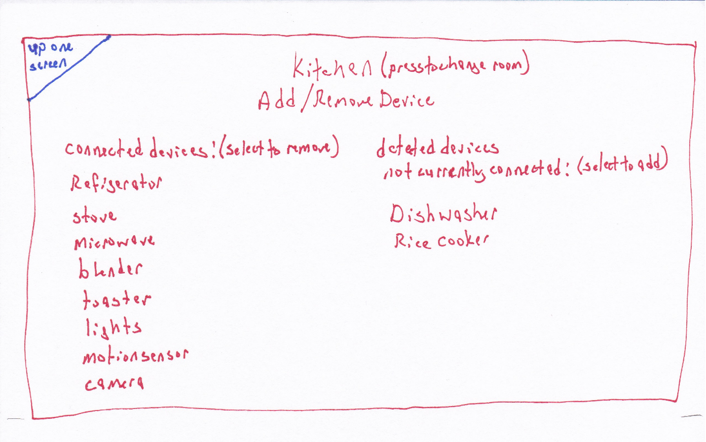

**Figure 4:** Settings per device per room in the “Add/Remove device” option. Connected and not-connected devices are listed separately.

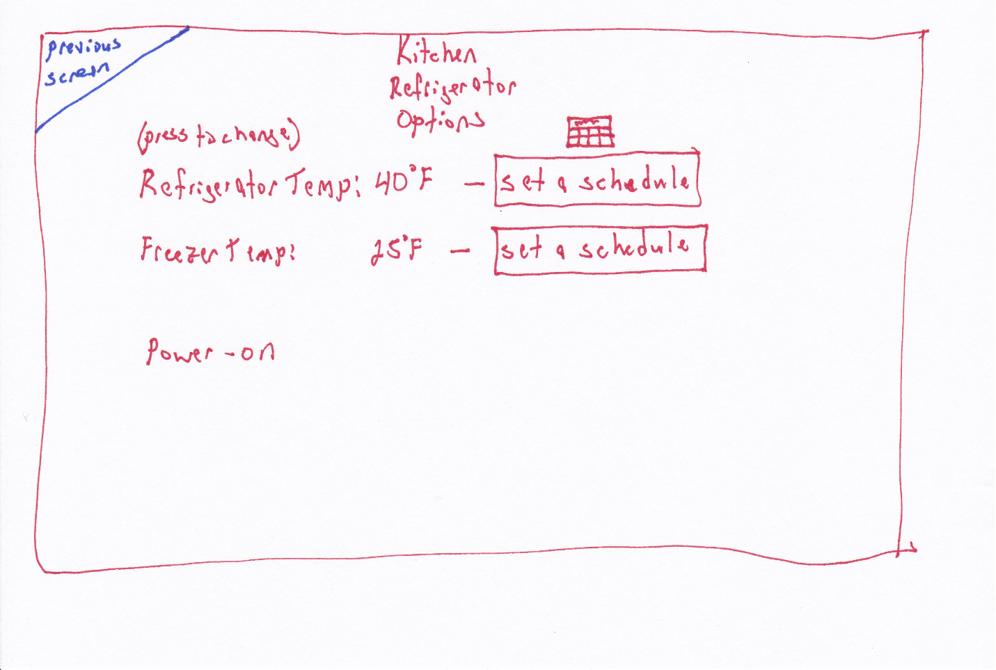

**Figure 5:** Specific device settings, a graphic and text is used to denote scheduling, the graphic chosen is of a calendar page to indicate that long-term schedules can be created as opposed to a clock that could indicate per-day time scales.

**Bridge of Execution:**

The user’s **plan** to set the freezer schedule can now be realized, there is a clear option to set the schedule for the freezer.

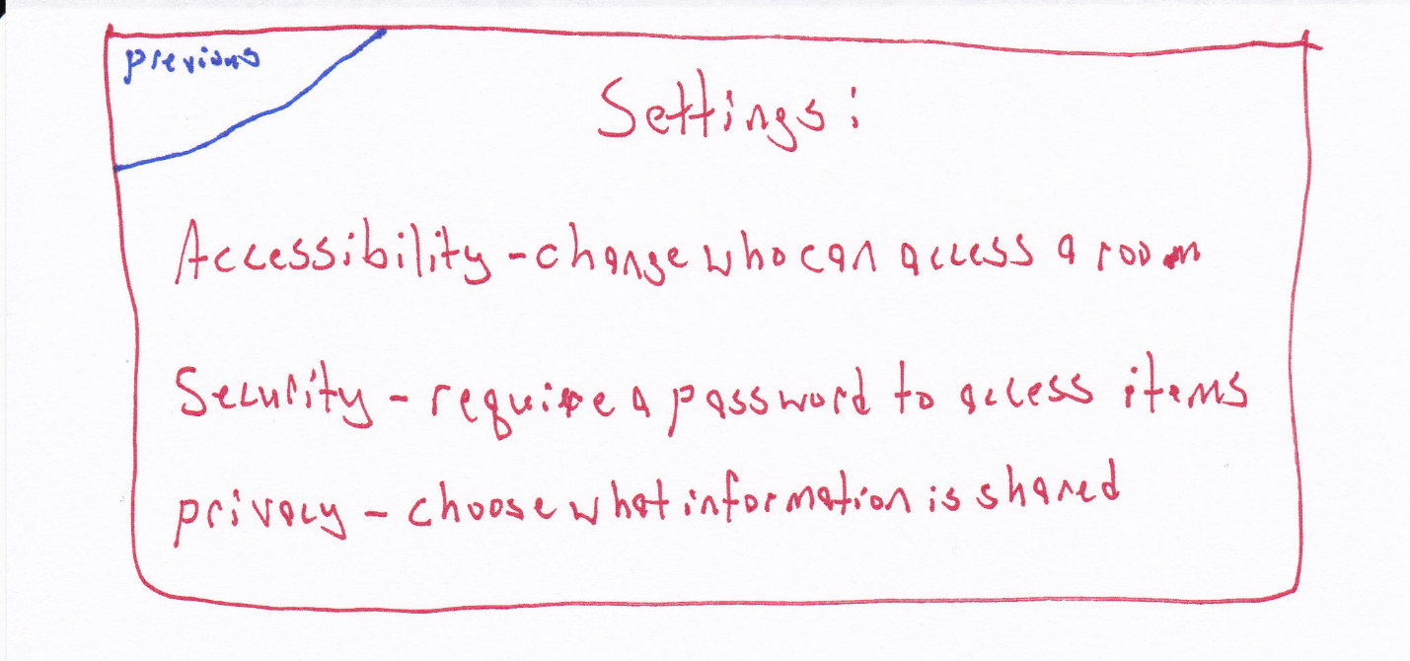

**Figure 6:** Update Settings

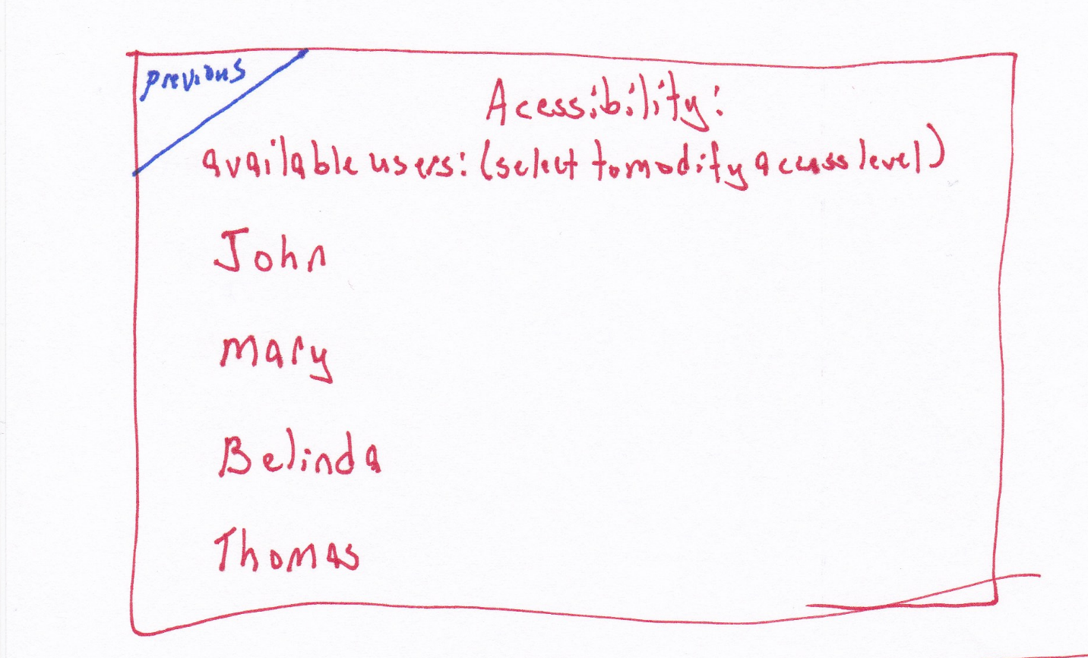

**Figure 7:** Accessibility settings can be set per user. If a user is to be prevented from adjusting a setting on a device, for example, the much controversial thermostat, then adjusting that setting will require a user name and password of an authorized user.

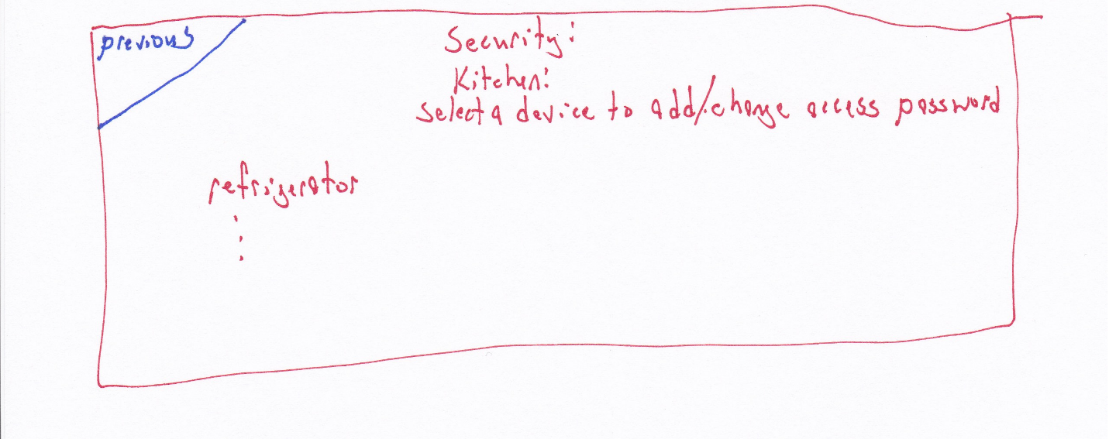

**Figure 8:** Security settings can be set for specific devices to require an authorized user and authenticating password to adjust.

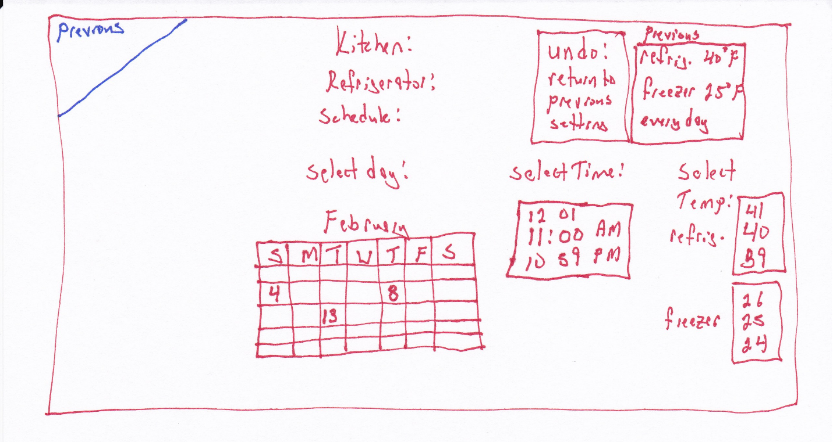

**Figure 9:** Scheduler allows the user to adjust the day and time a devices settings will be modified.

**Bridge of Execution:**

**Pictorial representations** of the calendar and clock augment the text that prompts the user to select a date, time, and temperature. It also provides an easy way to restore the settings with one touch.

**Bridge of Evaluation:**

Having the time one minute ahead above the current time and the time one minute below is supposed to indicate that the user can swipe the touch screen there to change the time. The temperature settings use the same mapping. This may be confusing to new users or it could be intuitive for users already very familiar with touch screens.

The previous setting data provides the user with information so they don’t have to recall it from the previous status screen. This is helping **to not burden the users memory**.

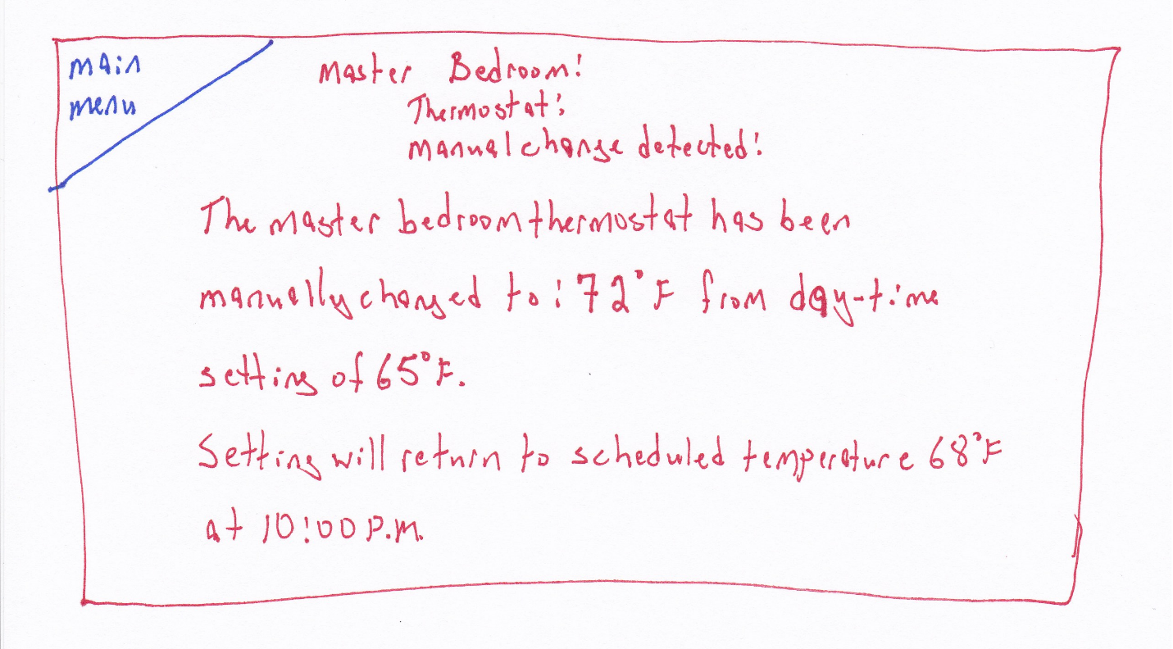

**Figure 10:** Status message after a device has been changed manually, the device that has been manually set is monitored by the manager for changes and those changes are displayed on the screen until they are acknowledged. If a user turns off a device so the system can no longer access it, it will be noted as “offline”.

Concept 2:

**Conceptual model:**

This design uses a simplified approach. There are fewer options and the user is guided more directly. The controllable devices have the statuses displayed as well as a graphical map of where they are in the room. The images will change color and image to show if a device is on or off. A lamp that is turned off will be a darkened circle, one that is on will be a yellow circle with lines radiating out from it. The user can press on either the device text status or click on the item in the image map to adjust its settings or set a schedule. For light sources that have variable brightness, a slide bar is provided to adjust the brightness. A back arrow combining graphic and text similar to a web browser is provided to allow the user to go back one screen.

**Affordances:**

The touch screen affords touching. The touch screen is ubiquitous and because of transfer effects, requires no explanation or instructions. With no visible physical buttons, users will assume a touch interface and press the area of the screen that displays the information that pertains to their desired action.

**Signifiers:**

Each screen is **consistently** labelled at the top to let the user know where they are in the menu. Parenthesized notes have been added to prompt the user to items that can be pressed for actions.

**Mapping:**

To choose a specific room, a map of the house is shown to provide a natural mapping to help the user select the correct room. This version shows each floor as a selectable object. Using a pictorial map and allowing the user to press on the room they wish to control removes any confusion.

**Feedback:**

When a user pushes on the screen, the screen will change to the new operation immediately showing them that the action was accepted. An audible notification can also be added if that is desired with a volume low enough to not be offensive but loud enough to be definitively noticed.

**Constraints:**

**Physical:**

The touch screen constrains all action to within the touchable area.

Cultural:

Semantic:

Logical:

**Transfer effects:**

Touch screens are ubiquitous.

**Bridge of execution:**

The user must know at each step what the next action needs to be. As the screen changes, so does the information the new screen provides. Each screen is clearly labelled with its title and any operations that can be performed on that screen are labelled as well.

**Bridge of evaluation:**

The user must know that the action they did was successful. When the screen changes to the next operation or values for settings change as the screen is touched let the user know they were successful.

Colors are used in a manner that will minimize the impact on color-blind users. Blue text on a white background provide sufficient contrast for users of all color-blind ranges.

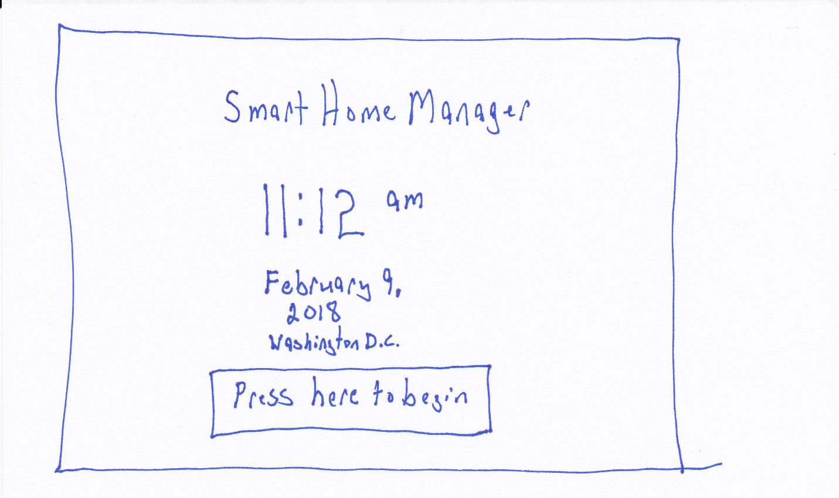

**Figure 1:** main

**Bridge of Execution:**

The large button labelled “Press here to begin” simplifies the interface and makes it clear what action is required to access the device.

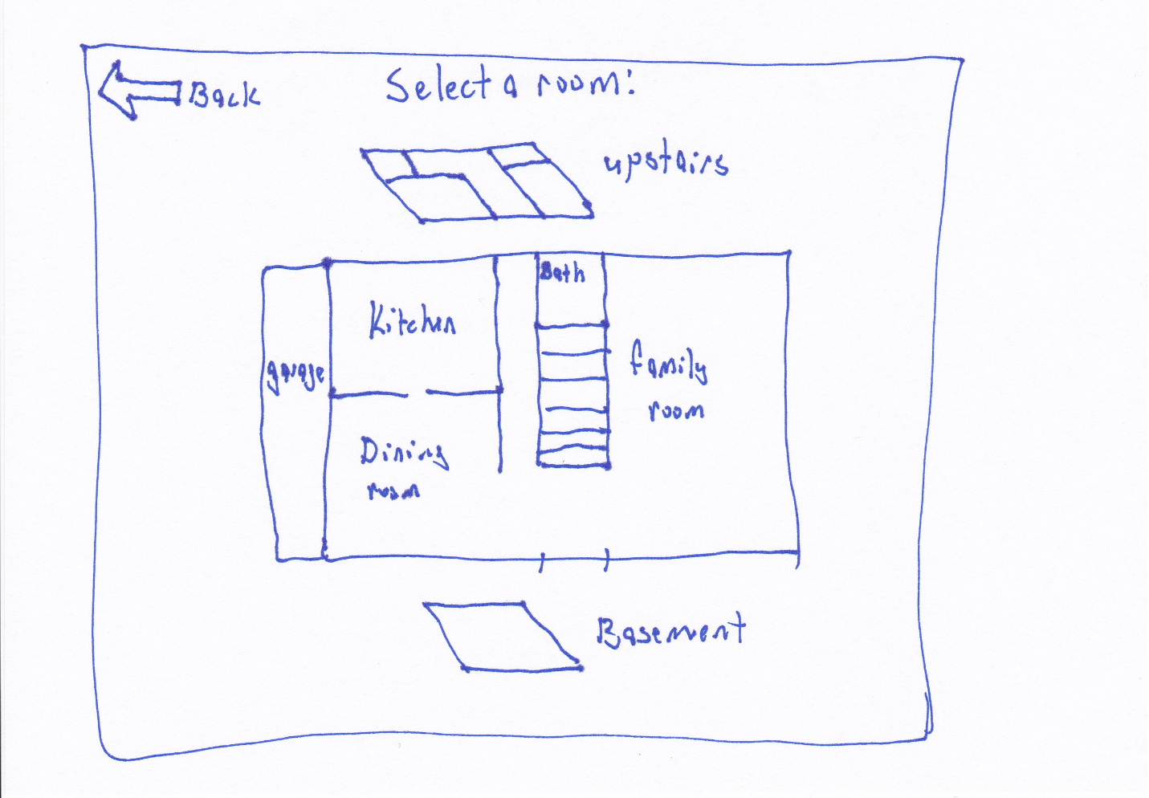

**Figure 2:** select room

**Bridge of Execution:**

The pictorial representation of the house is intended to be an actual map of the house floor plan. Each room is labelled and touching that room will move to the next screen to show what is available in that room.

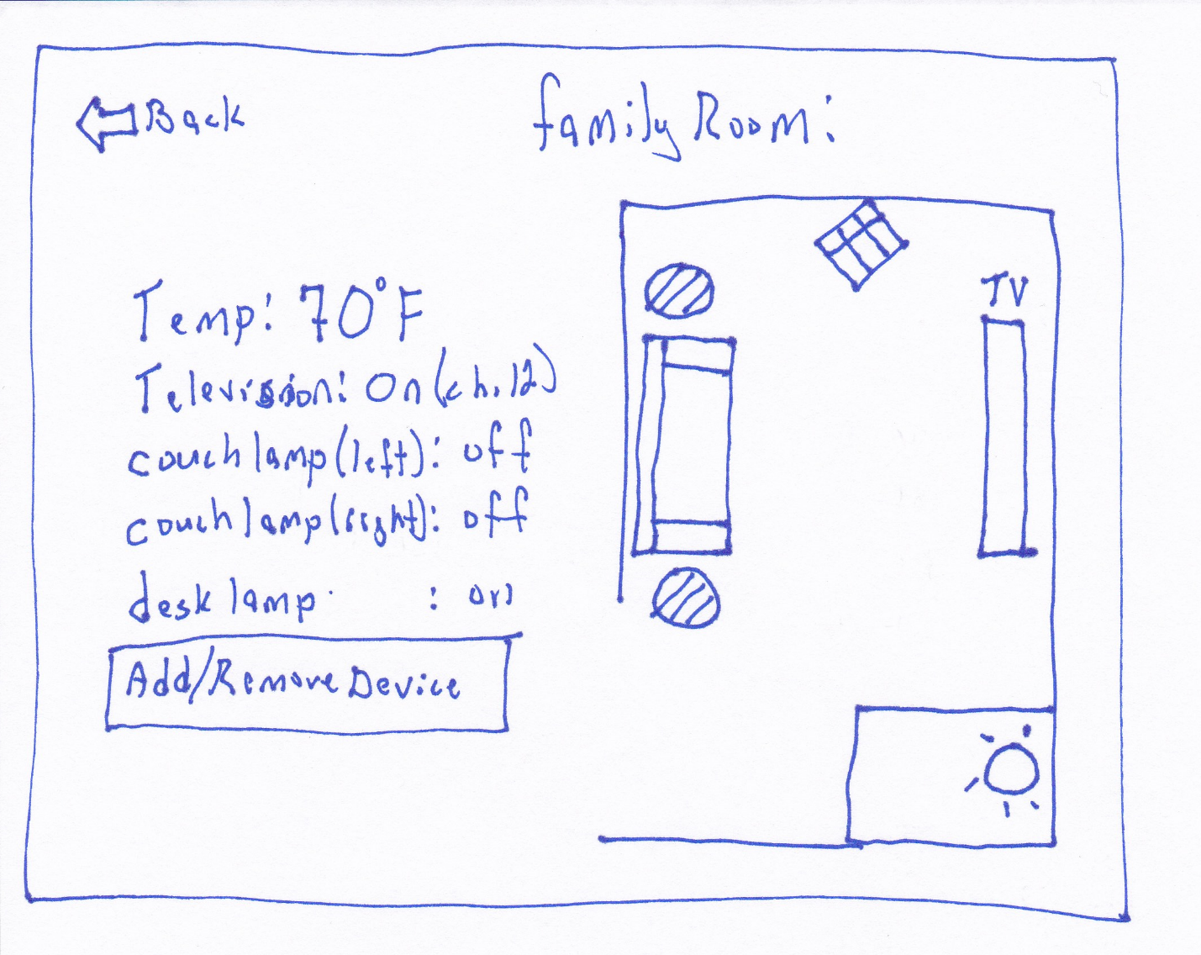

**Figure 3:** Per room status

**Bridge of Execution:**

The graphics on this display are intended to make it apparent which devices are on by illuminating them. The user can touch the device icon or the device name in the status to adjust the settings.

**Bridge of Evaluation:**

It is not explicitly specified that the user can adjust an item by touching its icon or its status, a **signifier** should be added.

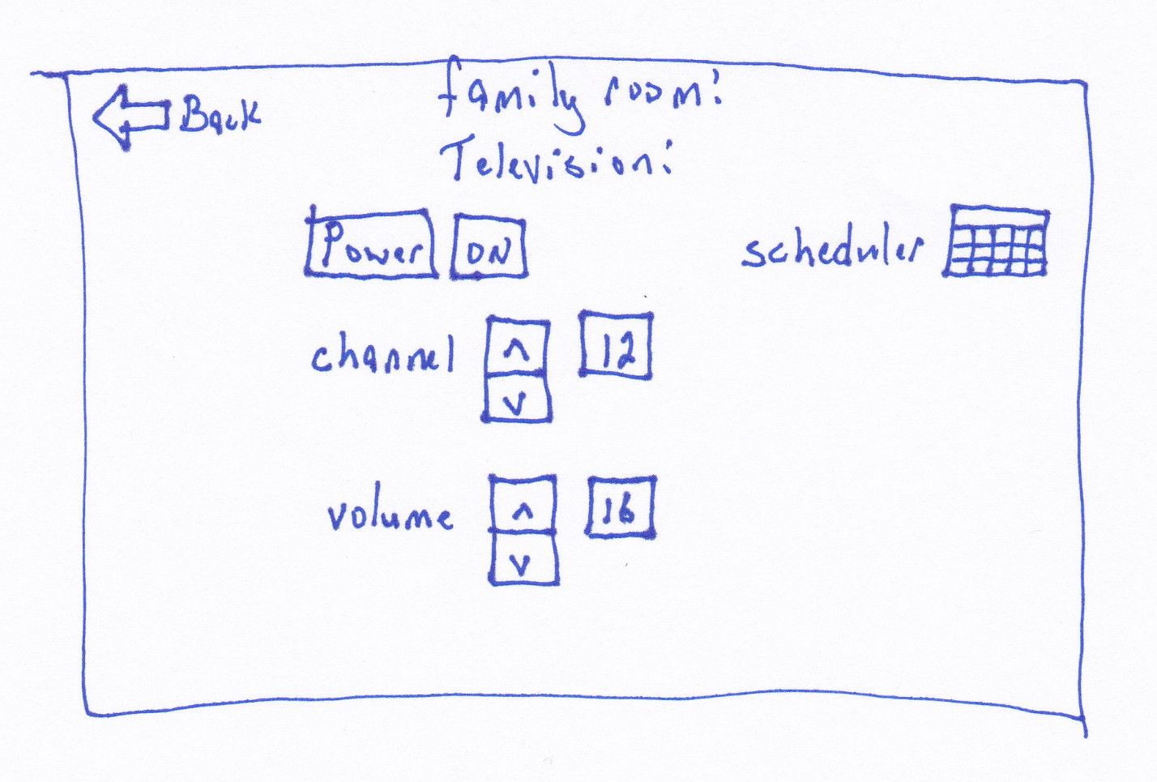

**Figure 4:** device settings

**Bridge of Execution:**

The television controls resemble a traditional television remote to leverage **transfer effects**. The icon-augmented label of “Scheduler” is intended to be apparent that touching this icon will allow the user to create a schedule for the television.

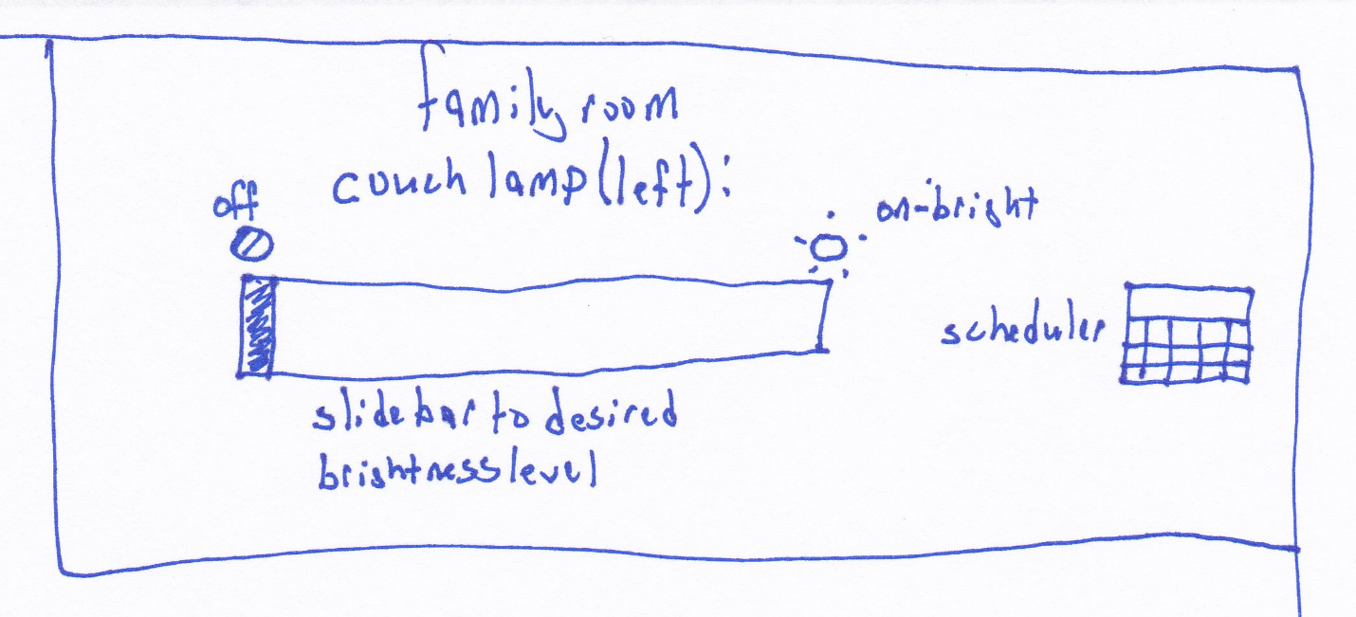

**Figure 6:** Lamp settings

**Bridge of Execution:**

The slide bar is intended to provide the user with the ability to control brightness similar to a physical slide switch on some dimmable lights.

**Bridge of Evaluation:**

The slide bar might be confusing, it is possible that providing discrete values for the user to click on might be easier to understand.

**Final design:**

1. Reduce the number of design concepts
2. Choose the most promising design(s) concept as a starting point

The most promising concept is concept 1. Based on feedback received during the in-class exercise on Thursday, February 8, the floor-plan imagery was not well-received.

The impromptu focus group indicated that due to the myriad of variations in house floor plans that the initial setup would be too difficult and that few people would bother.

**How this design addresses specific design principles:**

**Johnson:**

**• Ch. 1: Human perception is biased – Avoid ambiguity in information displays**

**– Be consistent**

* The layout of each page follows the same structure:
  + title at the top
  + previous menu in upper left corner
  + Center items if they can fit a single column
    - Use vertical symmetry about the center if multiple columns
  + Colors and fonts are the same on all screens
  + Language is simple, descriptive

**– Understand users’ goals**

**• Ch. 2: Human perception optimized to see structure – Gestalt principles**

**Gestalt principles:**

* **Proximity**
  + Similar items are grouped together and clearly separated from non-similar items
* **Similarity**
  + All buttons use the same button image
  + Elements that have different functions have different appearance. The title looks different from buttons in that it is just text.
* **Continuity**
  + Was not utilized
* **Closure**
  + Not utilized
* **Symmetry**
  + In instances when the amount of buttons to display cannot be easily displayed in a single column, the multiple columns are displayed symmetrical about the vertical center axis.
* **Figure / ground**
  + The on-screen keyboard will need shadowing to suggest that it is in the foreground
* **Common fate**
  + Not utilized

**• Ch. 3: Humans seek and use visual structure – Impose visual structure on information displays**

* A visual hierarchy is used by always putting the title of the page at the top with any sub-title name below it and if relevant, the page function below that. The actionable elements are then placed on the screen below in a structured format.

**• Ch. 4: Color vision is limited – Use color redundantly with other cues**

**– Make sure colors are distinguishable, even for colorblind**

* The color scheme was chosen to be simple and contrasting. Red text dominates on a white background with blue and black used sparingly. The colors chosen are ones that are not common problem colors for color-blind people.

**• Ch. 5: Peripheral vision is poor – Use a combination of movement, color, different font to make things stand out in periphery and optimize visual search**

* This design tries to minimize the periphery by keeping elements mostly around center with wide space at the edges to avoid being perceived as cramped. Each page is limited to a single function to avoid the need to search excessively for elements.

**• Ch. 6: Reading is unnatural – Avoid unfamiliar words, difficult fonts, poorly contrasting backgrounds**

**– Minimize text in interfaces**

The language used is common to native American speakers and should be customized if this product is to be used in other countries. The verbiage is intentionally terse, trying to say what needs to be said as brief as can be still understood. By keeping each window restricted to a single function, it reduces the amount of instruction needed and allows the visual elements to “paint a picture” for the user to determine the screens purpose without needing more text explanation.

**Designing with human memory in mind:**

* Place instructions in context in which they’re needed
  + All instructions are placed in parenthesis next to the title of the section they are in
* Make modes visible
  + This design does not utilize multiple modes
* Focus user on single subtask in multi-step sequences
  + Each screen has one common group of related functions
* Provide users with assistance in recalling security credentials
  + OK
* Be consistent in placement of UI elements across pages / apps
  + Each screen is consistent in the placement of the title, sub-title, and arrangement of buttons
* Make changes to objects / states in UI obvious
  + Each new window has a visual difference to the one before it. The content changes in quantity and creates noticeable shifts in the button locations but the shifts are not too different to create confusion.
* Provide / support external memory aids of progress
* Remind users of “loose ends” at end of task
* Anticipate user’s goals and match options to goals
* Make commonly -used functionality easy to access
* Show available options rather than requiring them to be remembered
  + Each screen is labeled below the title with its purpose and each option is labelled in text to clearly indicate what can be done on that screen
* Represent options with both pictures and text to enhance recognizability
  + In locations where reasonable graphical representations could be placed, they have been placed
* Make range of choices readily distinguishable
  + The button imagery has been added to distinguish each option and to make it clear that they are selectable options
* Use thumbnail images to index previously-viewed images

1. Produce 10 details and / or variations of a particular design concept

|  |
| --- |
| • ***Users must be able to configure other device settings.***It must be possible to:   * configure other device specific settings, i.e. the smart home manager interface settings. Examples could be (***but not limited to***) * device network connectivity (wired? wireless?), * brightness settings, * security, * privacy, * accessibility settings, * etc.   Users are able to configure device settings per device by selecting the device when it is displayed in either the room view or the function view. See **figure 3**.  • ***Users must be able to add and remove connected smart devices.***One of the advantages of many smart devices is the ability to add and remove from the system as desired (i.e., they are not stand-alone devices). The interface must support adding and removing any compatible smart devices.   * In the status window, the system will search for any wi-fi enabled device that is powered on and available. If the device is already connected, it is displayed in a list of connected devices and each device can be selected to be removed from the system. Any device that is detected but not yet connected is displayed on a separate, clearly identified list and the user can choose to connect the device. Any necessary settings can be set at that point.   • ***Users must be able to monitor all connected device statuses.***As a smart home user, it is expected that all connected devices should have a status (e.g. connection or other data made available via the connected device).   * This design provides two status screens, one shown, **figure 3**, displays all devices per room, another will show all devices by function. The current status of the device is clearly indicated and the user can select the device to make adjustments.     • ***Users must be able to manually control individual devices.***Sometimes, a user will want to manually adjust individual device settings. The interface must support interacting with individual device settings (which will vary by device and supported feature set / available device APIs). At a minimum it should support on/off with the ability to handle more advanced control sets based on device complexity.   * Assuming that the smart devices themselves provide two-way communication, the system will monitor changes made at the device outside the smart home manager system. A modification to a setting on a device will be recorded by the system as the new setting and will display a message on the screen alerting the user to the change. The user can acknowledge the message to return the system to normal operation.     • ***Users must be able to create, modify, and remove automated tasks.***A user must be able to input a specific automated task for any of their connected smart devices. Automated tasks should support (***but not be limited to***) time scheduled activation (on/off) as well as support for custom scripts to provide more advanced automation (e.g. via device APIs).   * See **figure 5b** for the latest iteration of this design element. The user can see the current status of all elements of a specific device and make all possible changes including setting a schedule and password. |
|  |

Concept 1A: Revision of Concept 1:

The Accessibility screen has been removed. On reflection, it didn’t make sense to set access levels per user since each device can be given a password.



**Figure 1:** Main screen – before

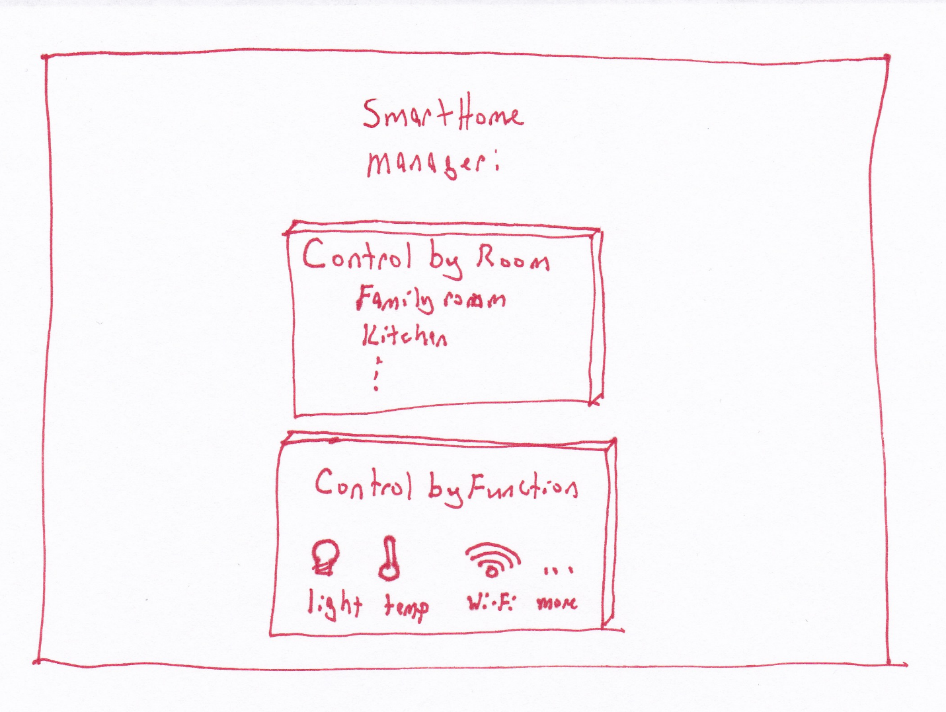

**Figure 1b:** Main screen – redesigned, the options are laid out in a manner that is **consistent** with the button placements on the other screens.

**Iterative design** based on feedback from **focus group**, the graphical floor-plan is replaced by a text list of rooms. It was believed, by the majority, that the difficulty of creating a custom layout would be a barrier to the user.

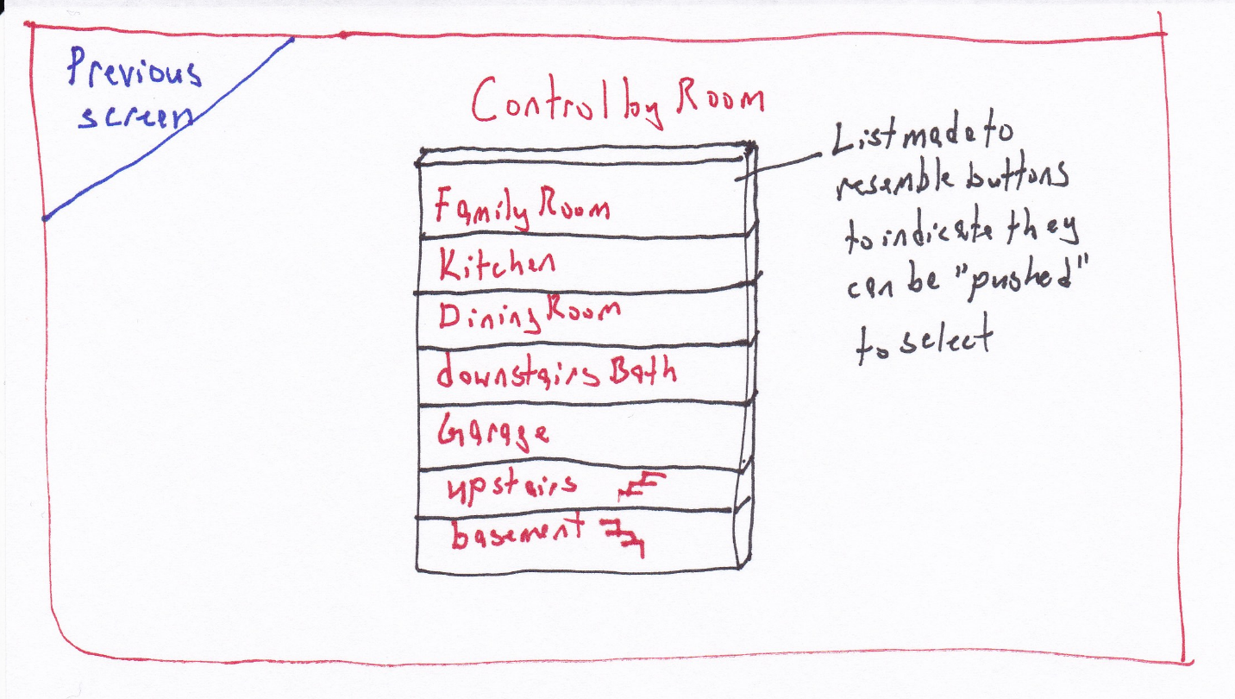

**Figure 2:** updated display for “Control by Room” option.

The floor-plan graphic is replaced by a list. The list is presented on button images, **combining text and images** to indicate that they can be pressed / touched to select that room.

The button graphic around each selectable option has been added to all screens to maintain **consistency**. This adds to the **bridge of execution** as the user has a better idea of what they need to do next.

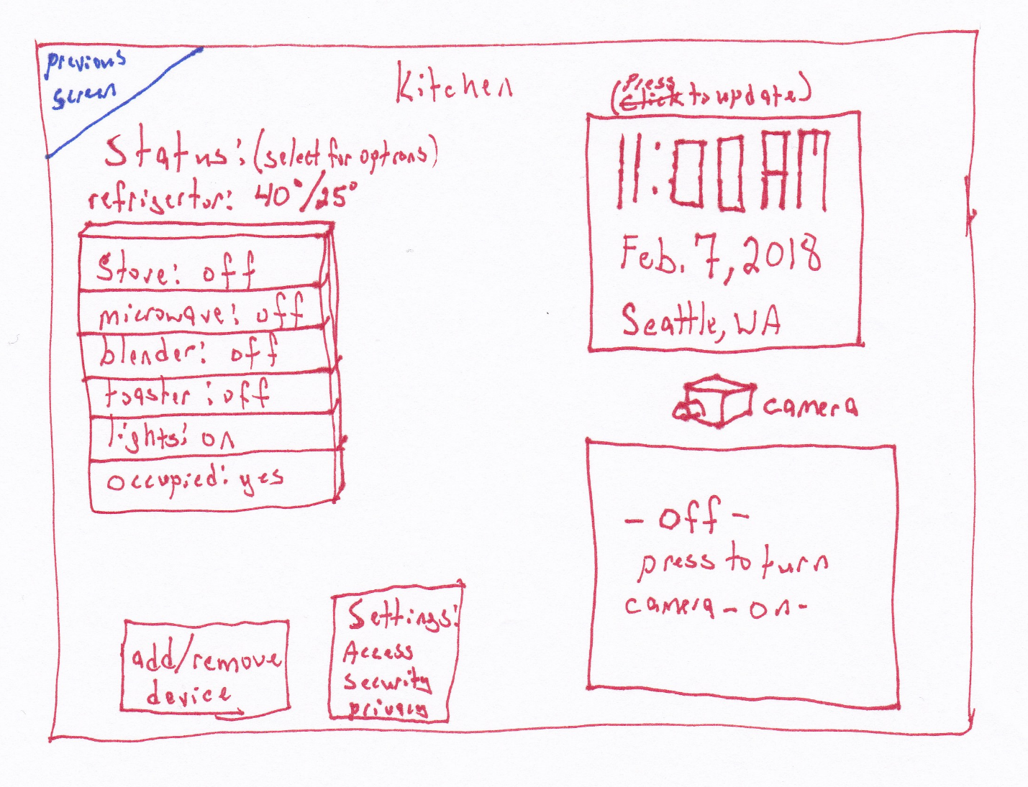

**Figure 3:** Status by room with options to change the settings for each device, add or remove devices, change system settings (this is available in all room displays). The camera and video option can be made to only appear if the room has an enabled camera. It the camera is not installed for a room or has been otherwise disabled, this option will not appear but will be a blank part of the screen. The position of the other elements will not change to preserve window-to-window consistency.

**Bridge of Execution:**

The refrigerator status is shown on the status display and the Status heading states that the user can press the device for more options. The statuses are displayed on button images to indicate to the user that they can be pushed for more options. This **reinforces** the parenthesized instructions in the sub-window title that states to select a device for more options.

**Bridge of Evaluation:**

As users press an option, the screen changes to the next option so they know what to do next.

**Gestalt principle of Proximity:**

Common, related items are grouped next to each other in the status area and the two buttons for add/remove device, and settings.

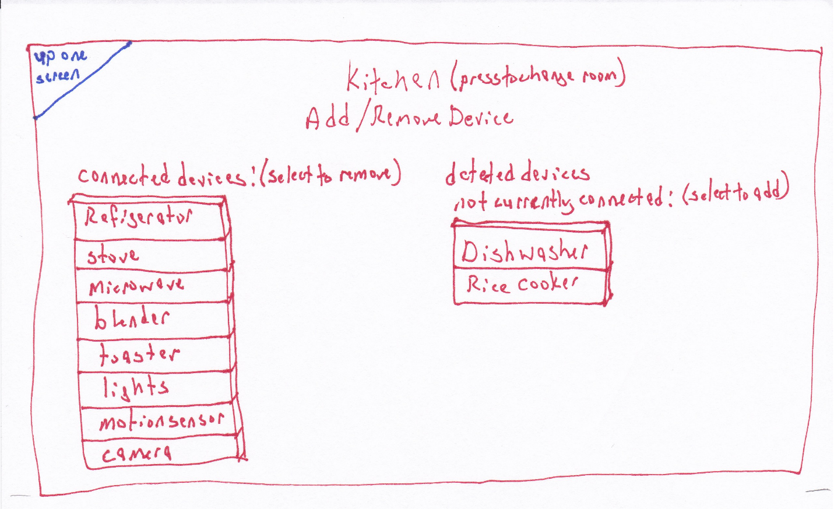

**Figure 4:** Settings per device per room in the “Add/Remove device” option. Connected and not-connected devices are listed separately.

**Gestalt principle of Proximity:**

The currently connected items are grouped together and have a measurable distance between them and the detected, not yet connected devices which are also grouped together.

**Bridge of execution:**

The lists of devices for both connected and detected, not yet connected have had button imagery added to better indicate that they can be selected. The parenthesized instructions in the title of the sub-windows let the user know what selecting each device will do, for connected devices, it will disconnect them, for not yet connected devices, it will connect them. Performing either action will cause the item to move to the opposite list.

**Bridge of evaluation:**

Selecting any item from either list will result in it disappearing from that list and appearing on the opposite list providing visual **feedback** to the user that the action completed successfully.

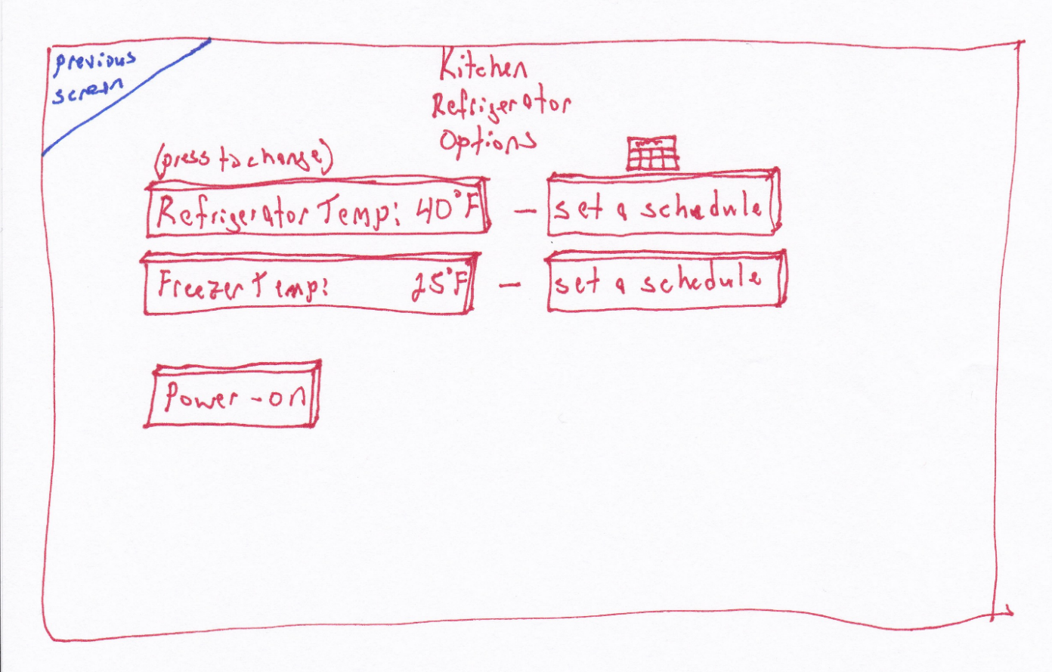

**Figure 5a:** Specific device settings, a graphic and text is used to denote scheduling, the graphic chosen is of a calendar page to indicate that long-term schedules can be created as opposed to a clock that could indicate per-day time scales.

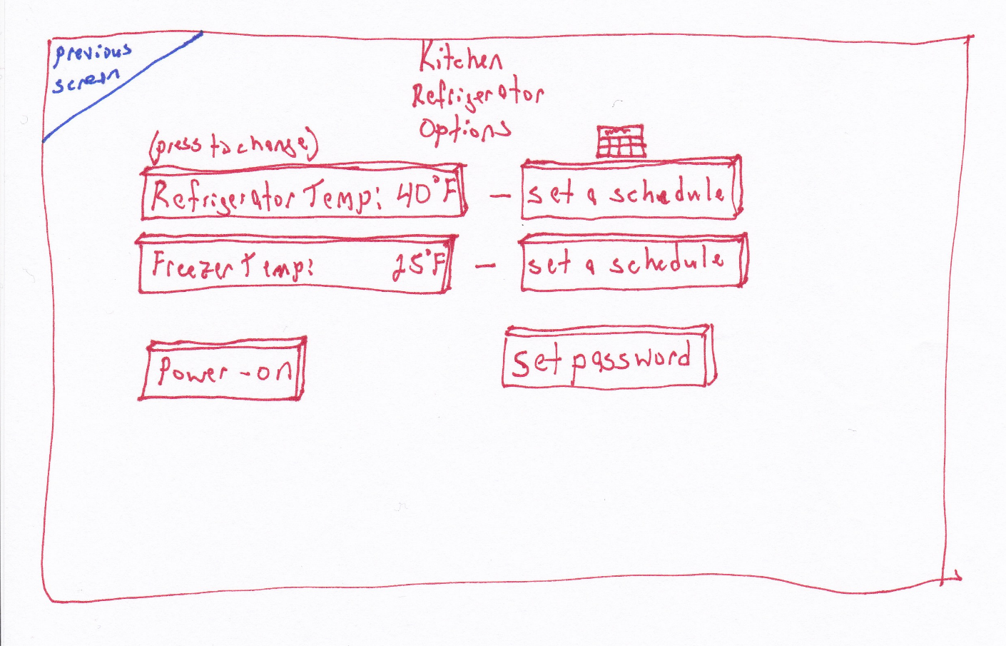

Figure 5b: Revised – set password button added

**Bridge of Execution:**

The user’s **plan** to set the freezer schedule can now be realized, there is a clear option to set the schedule for the freezer. Button imagery has been added to the current status displays to indicate to the user that they can select these options to change the temperatures, separate from the schedule function.

**Bridge of Evaluation:**

Pressing a button to change the temperature will bring up a new window allowing the user to perform the new action. Pressing a button to set a schedule will take the user to a new window with the calendar and clock features prominently featured letting the user know just what action they can perform next.

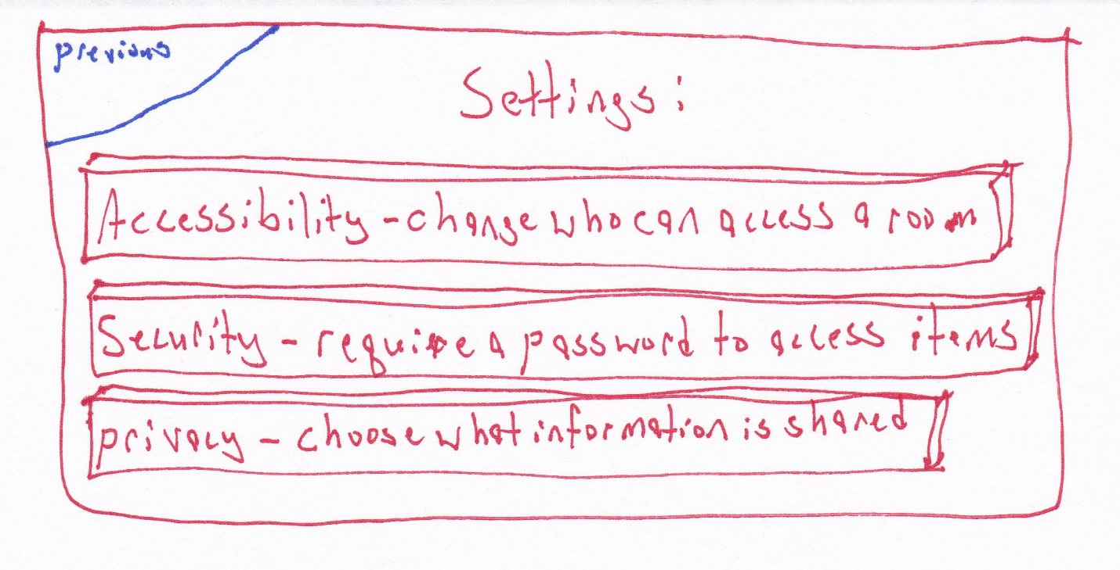

**Figure 6a:** Update Settings, before

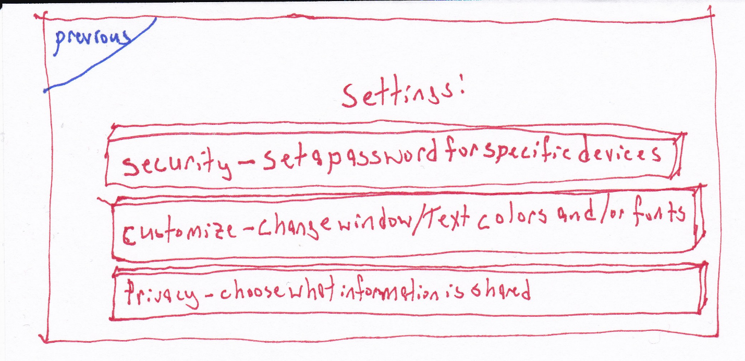

**Figure 6b:** Update Settings revised

**Bridge of Evaluation:**

Each button has text on it that describes what that button will do. The button imagery has been added to indicate to the user that they can be pushed to select that option. The accessibility option was removed as it did not make sense after the complete design was considered. The option to change colors and fonts was added to provide the user with customization options.

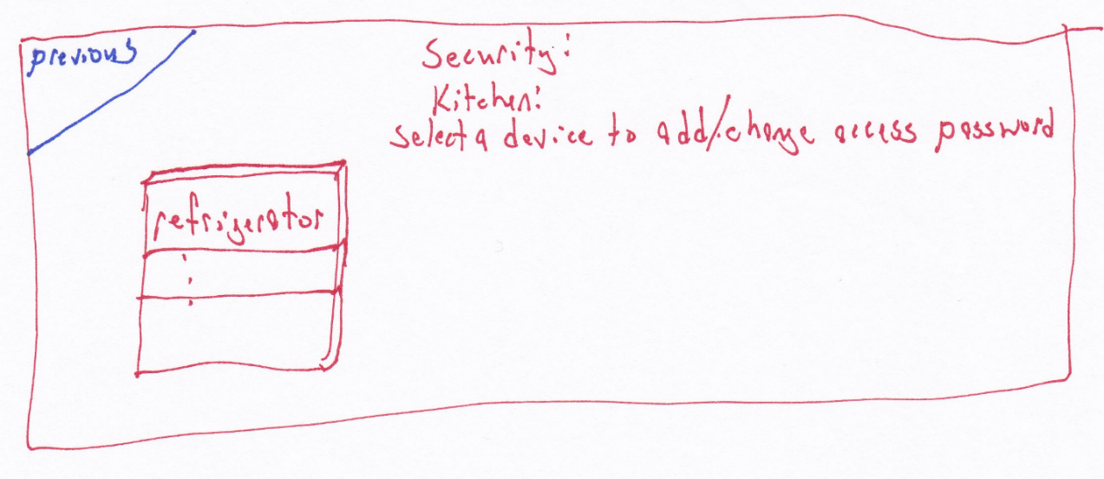

**Figure 7a:** The old Security settings page, has been replaced.

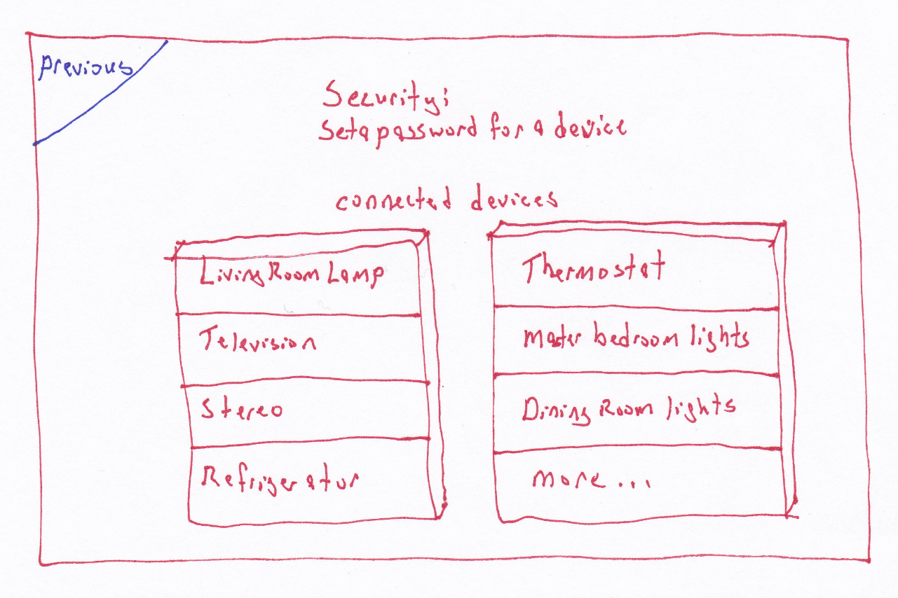

**Figure 7b:** Revised security settings page. Each device is listed as a button that the user can choose to add / change a password for that device.

**Bridge of Execution:**

The parenthesized instructions indicate that selecting a device from this screen will allow a user with proper access to add or change a password for a device. This is a per-device security setting and is independent of user, anyone with the device password can modify the settings for that device. The previous iteration was intended to be selected from within a specific room but a new button has been added to the specific device to replace this (Figure 5)

**Bridge of Evaluation:**

Selecting a device from this screen will bring up a sub-window prompting the user to select a password using an on-screen keyboard and confirm it.

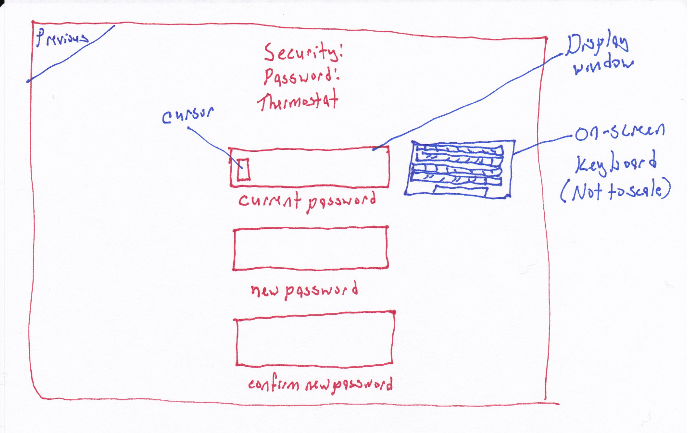

**Figure 8:** Add / Change password for a device



**Figure 9:** Scheduler allows the user to adjust the day and time a devices settings will be modified. This screen is unchanged from the first draft.

**Bridge of Execution:**

**Pictorial representations** of the calendar and clock augment the text that prompts the user to select a date, time, and temperature. It also provides an easy way to restore the settings with one touch.

**Bridge of Evaluation:**

Having the time one minute ahead above the current time and the time one minute below is supposed to indicate that the user can swipe the touch screen there to change the time. The temperature settings use the same mapping. This may be confusing to new users or it could be intuitive for users already very familiar with touch screens.

The previous setting data provides the user with information so they don’t have to recall it from the previous status screen. This is helping **to not burden the users memory**.

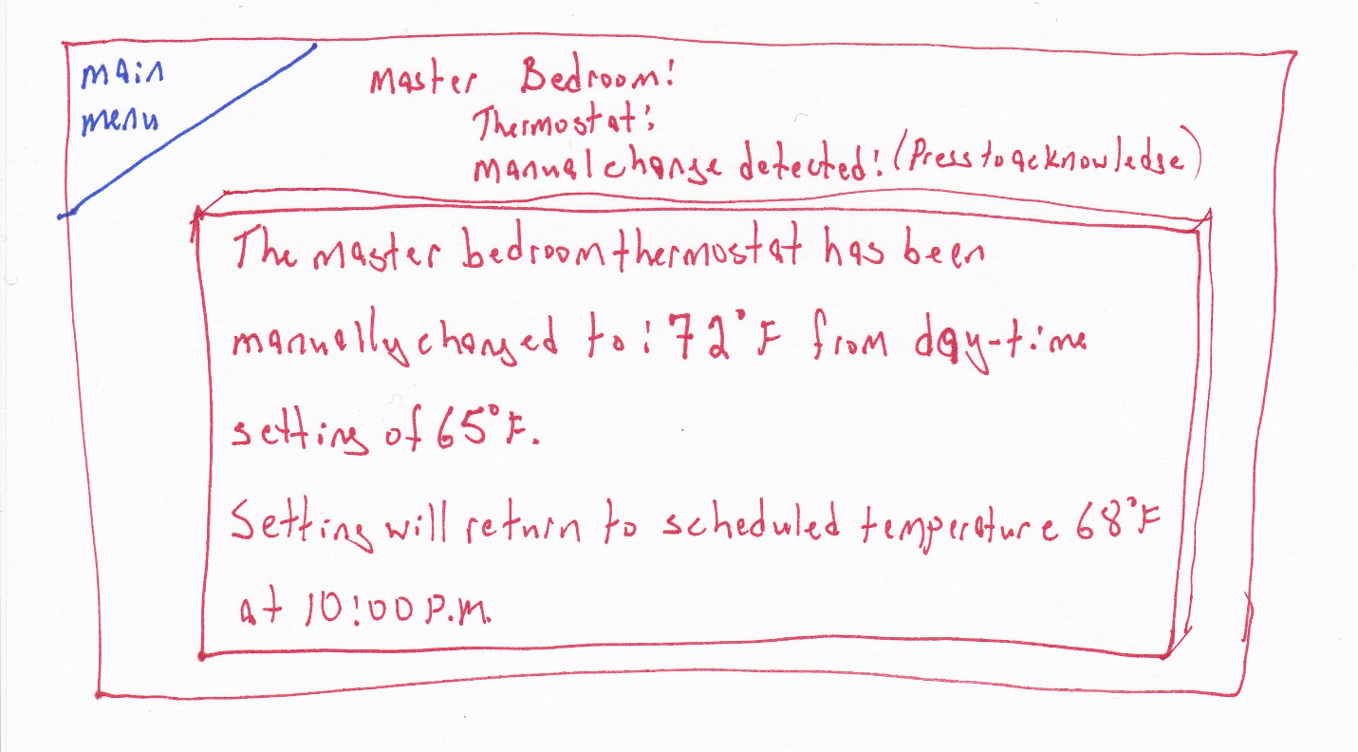

**Figure 10:** Status message after a device has been changed manually, the device that has been manually set is monitored by the manager for changes and those changes are displayed on the screen until they are acknowledged. If a user turns off a device so the system can no longer access it, it will be noted as “offline”.

1. Present your best idea(s) to a group

This was done in-class during the impromptu focus group.

1. As your ideas change, sketch them out